Contents
• What do we require microservice and features of it? 2
• Diff between the Monolithic, SOA, and Microservices 4
• What is blue green deployment? 4
• What is Saga pattern in microservices? 4
• What is Circuit Breaker in microservice? 5
• How to microservices communicate with each other in spring boot? 6
• Diff between the synchronous and asynchronous in microservices 6
• Why spring deprecated the rest template? or it’s disadvantaged? 7
• What is API gateway? 7
Resources:https://www.geeksforgeeks.org/system-design/what-is-api-gateway-system-design/ 7
• What is Spring Cloud? 7
• Tell me about some design pattern in microservice? 8
• What is Hystrix in microservice? 8
Resources: https://www.geeksforgeeks.org/advance-java/spring-cloud-netflix-hystrix/: 9
• What is Discovery Service in microservice? 9
Resources: https://medium.com/@jeslurrahman/understanding-service-discovery-in-microservices-architecture-2098b10e7439 9
• What is resilience in microservices? 9

What do we require microservice and features of it?
Microservices are an architectural approach to developing software applications as a collection of small, independent services that communicate with each other over a network. Instead of building a monolithic application where all the functionality is tightly integrated into a single codebase, microservices break down the application into smaller, loosely coupled services.
Agility
Microservices foster an organization of small, independent teams that take ownership of their services. Teams act within a small and well understood context and are empowered to work more independently and more quickly. This shortens development cycle times. You benefit significantly from the aggregate throughput of the organization.
Flexible Scaling
Microservices allow each service to be independently scaled to meet demand for the application feature it supports. This enables teams to right-size infrastructure needs, accurately measure the cost of a feature, and maintain availability if a service experiences a spike in demand.
Easy Deployment
Microservices enable continuous integration and continuous delivery, making it easy to try out new ideas and to roll back if something doesn’t work. The low cost of failure enables experimentation, makes it easier to update code, and accelerates time-to-market for new features.
Technological Freedom
Microservices architectures don’t follow a “one size fits all” approach. Teams have the freedom to choose the best tool to solve their specific problems. As a consequence, teams building microservices can choose the best tool for each job.
Reusable Code
Dividing software into small, well-defined modules enables teams to use functions for multiple purposes. A service written for a certain function can be used as a building block for another feature. This allows an application to bootstrap off itself, as developers can create new capabilities without writing code from scratch.
Resilience
Service independence increases an application’s resistance to failure. In a monolithic architecture, if a single component fails, it can cause the entire application to fail. With microservices, applications handle total service failure by degrading functionality and not crashing the entire application.
Decentralized Data Management
In microservices, each service can manage its own database or storage system. This avoids the bottlenecks of a single centralized database and gives each team flexibility in choosing the right storage solution (SQL, NoSQL, in-memory, etc.) for their service. It also improves scalability and fault isolation since one database failure won’t necessarily impact the whole application.
Organizational Alignment
Microservices mirror the business domain—each service often represents a business capability (like payments, user management, or inventory). This alignment makes it easier for teams to take ownership of specific business functions and evolve them independently.

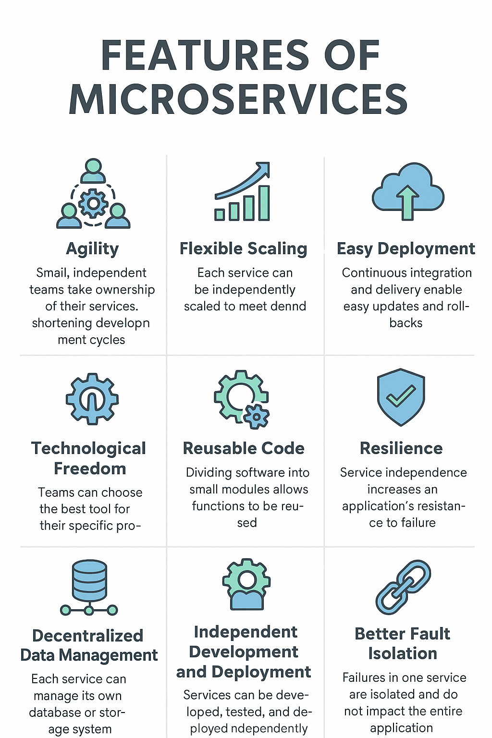

Diff between the Monolithic, SOA, and Microservices
Features | Monolithic | SOA | Microservices
Structure | A single application where all software components are assembled and tightly coupled. | Collection of services and loosely coupled. | Collection of small services and services independently deployable.
Communication | Within the same application, components communicate with each other. | Using some standardized protocols, services communicate with each other. | Through some lightweight protocols, all the services communicate with each other.
Scalability | Scaling is required according to the needs of the entire application. | All services can be scaled independently. | All the services can be scaled independently according to the business requirement.
Development and Deployment | It maintains centralized development and components deployed as a single unit. | It also maintains centralized development and here the services are deployed as monolithic applications. | It maintains decentralized development and services deployed independently.

What is blue green deployment?
A blue/green deployment is a deployment strategy in which you create two separate, but identical environments. One environment (blue) is running the current application version and one environment (green) is running the new application version. Using a blue/green deployment strategy increases application availability and reduces deployment risk by simplifying the rollback process if a deployment fails. Once testing has been completed on the green environment, live application traffic is directed to the green environment and the blue environment is deprecated.

Resource: https://docs.aws.amazon.com/whitepapers/latest/overview-deployment-options/bluegreen-deployments.html

What is Saga pattern in microservices?
The Saga pattern is the way of handling the transaction in distributed service.The saga pattern is a failure management pattern that helps establish consistency in distributed applications, and coordinates transactions between multiple microservices to maintain data consistency. A microservice publishes an event for every transaction, and the next transaction is initiated based on the event's outcome. It can take two different paths, depending on the success or failure of the transactions.

Resources: https://www.baeldung.com/cs/saga-pattern-microservices#1-what-is-saga-architecture-pattern

What is Circuit Breaker in microservice?
A circuit breaker in microservices is a design pattern that acts as a protective shield to prevent a failure in one part of the system from affecting the rest. It works similarly to an electrical circuit breaker, stopping requests to a service that appears to be failing.
This pattern is inspired by the electrical circuit breaker, which automatically opens the circuit if the current flow exceeds a certain threshold. This prevents the circuit from overheating and causing a fire.
In a microservices architecture, it works the same way, monitors the health of a microservice and automatically blocks requests from that service if it becomes unhealthy.
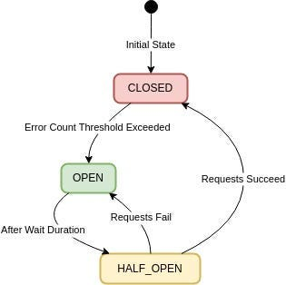

The circuit breaker has three states:
Closed:
In this state, the circuit breaker allows normal service communication, and requests go through to the service.
Circuit breaker monitors the responses from the service for errors. If the responses are successful with no issues, it remains in the closed state.
Open:
When the number of failures reaches a threshold, the circuit breaker switches to the open state, preventing requests from reaching the service and providing a fallback response.
(Threshold Value like 5 failures within 10 seconds)
Half-Open:
Once the timeout or reset interval passes, the circuit breaker goes to the “Half-Open” state.
It allows a limited number of test requests to pass through to the service to see if the service has recovered or not.
If the test requests succeed, it means the service has recovered and the circuit breaker goes back to “Closed” state.
If any of the test requests fails, it means the service has still issues and the circuit breaker goes to “Open” state to block further requests.

Resources: https://medium.com/@minadev/circuit-breaker-pattern-in-microservices-9568320f2059#:~:text=Circuit%20Breaker%20is%20a%20design,tolerance%20of%20a%20distributed%20system.

How to microservices communicate with each other in spring boot?
Synchronous Way
- REST Template
- Feign
Asynchronous Way (Using message broker)
- Active MQ
- Apache Kafka

Resources: https://www.geeksforgeeks.org/different-ways-to-establish-communication-between-spring-microservices/

Diff between the synchronous and asynchronous in microservices
Synchronous Transmission | Asynchronous Transmission
In Synchronous transmission, data is sent in form of blocks or frames. | In Asynchronous transmission, data is sent in form of bytes or characters.
Synchronous transmission is fast. | Asynchronous transmission is slow.
Synchronous transmission is costly. | Asynchronous transmission is economical.
In Synchronous transmission, the time interval of transmission is constant. | In Asynchronous transmission, the time interval of transmission is not constant, it is random.
In this transmission, users have to wait till the transmission is complete before getting a response back from the server. | Here, users do not have to wait for the completion of transmission in order to get a response from the server.
In Synchronous transmission, there is no gap present between data. | In Asynchronous transmission, there is a gap present between data.
Efficient use of transmission lines is done in synchronous transmission. | While in Asynchronous transmission, the transmission line remains empty during a gap in character transmission.
The start and stop bits are not used in transmitting data. | The start and stop bits are used in transmitting data that imposes extra overhead.
Synchronous transmission needs precisely synchronized clocks for the information of new bytes. | Asynchronous transmission does not need synchronized clocks as parity bit is used in this transmission for information of new bytes.
Errors are detected and corrected in real time. | Errors are detected and corrected when the data is received.
Low latency due to real-time communication. | High latency due to processing time and waiting for data to become available.
Examples: Telephonic conversations, Video conferencing, Online gaming. | Examples: Email, File transfer,Online forms.

Why spring deprecated the rest template? or it’s disadvantaged?
Spring deprecated the "RestTemplate" because it is a blocking, synchronous client, meaning it can't handle high-throughput scenarios efficiently, lacks support for reactive programming, and is considered outdated compared to the newer "WebClient" which offers a non-blocking, reactive approach, providing better scalability and performance in modern applications.
Key disadvantages of RestTemplate:
- Blocking nature:
A single thread is blocked while waiting for a response from the server, which can lead to performance issues in high-traffic scenarios.
- Limited scalability:
Due to its blocking behavior, RestTemplate struggles to scale effectively in distributed systems.
- No reactive programming support:
RestTemplate doesn't integrate well with reactive programming paradigms, which are increasingly important for building responsive applications

What is API gateway?

Resources:https://www.geeksforgeeks.org/system-design/what-is-api-gateway-system-design/

What is Spring Cloud?
Spring Cloud is a framework built on top of Spring Boot that simplifies the development of distributed systems and microservices. When large applications are split into microservices, common challenges arise such as configuration management, service discovery, load balancing, inter-service communication, and resilience. Spring Cloud provides built-in tools and integrations to handle these challenges seamlessly.
Service Discovery
In a microservice environment, it is difficult to manage the network locations of services manually. Spring Cloud solves this by offering service discovery using tools like Eureka, Consul, or Zookeeper. Each microservice registers itself with the discovery server, and other services can locate it dynamically. This eliminates the need for hardcoding hostnames and ports, making the system more scalable and flexible.
Centralized Configuration Management
Managing configuration files across multiple services can be complex. Spring Cloud provides the Config Server, which stores all configurations in one centralized location (for example, a Git repository). This allows all services to fetch their configurations at runtime, ensuring consistency across environments like development, testing, and production. It also makes updates easier since changes can be applied without redeploying services.
Load Balancing
When multiple instances of a service are running, traffic needs to be distributed efficiently. Spring Cloud integrates with Ribbon (older) and Spring Cloud LoadBalancer (modern approach) to provide client-side load balancing. This ensures requests are spread evenly across service instances, improving both availability and performance.
Fault Tolerance and Resilience
In microservices, one failing service should not cause the entire application to fail. Spring Cloud provides integration with Resilience4j and previously Hystrix to implement circuit breakers, retries, and fallback mechanisms. These tools help applications handle failures gracefully by degrading functionality instead of crashing completely, making the system more reliable.
API Gateway
In a microservices system, clients often need to communicate with multiple services. Instead of exposing every service directly, Spring Cloud provides the Spring Cloud Gateway, which acts as a single entry point. It handles request routing, authentication, logging, rate-limiting, and monitoring. This simplifies client communication and adds an extra security layer to the system.

Distributed Tracing and Monitoring
Since requests often pass through multiple services, tracing them is essential for debugging and performance analysis. Spring Cloud offers Sleuth and Zipkin for distributed tracing. Sleuth assigns unique trace IDs to requests, while Zipkin collects and visualizes logs across services, making it easier to track issues and monitor performance.
Event-Driven Communication
Spring Cloud also supports asynchronous communication between services using Spring Cloud Stream, which integrates with messaging platforms such as Apache Kafka and RabbitMQ. This enables the development of reactive microservices that exchange events efficiently, improving scalability and decoupling between services.

Tell me about some design pattern in microservice?
- API Gateway: A single-entry point for clients to access multiple microservices, handling routing, authentication, and rate limiting.
- Aggregator Pattern: Combines responses from multiple microservices into a single response for the client, useful when data needs to be aggregated from various sources.
- Circuit Breaker Pattern: A mechanism to handle failures gracefully by automatically failing fast and retrying later when a service becomes unavailable.
- Event-Driven Architecture: Services communicate through asynchronous events, allowing for scalable and decoupled interactions.
- Saga Pattern: Manages complex transactions spanning multiple microservices by breaking them down into smaller, locally consistent operations.
- CQRS (Command Query Responsibility Segregation): Separates data read operations (queries) from write operations (commands), often using different data models for each.

What is Hystrix in microservice?
In Spring Boot, Spring Cloud Netflix can be used to build the microservices architecture with the help of various components. In Spring Cloud Netflix, Hystrix is one of the components, and it can be used to stop cascading failures and enable resilience in complex distributed systems. It is a latency and fault tolerance library designed to isolate points of access to remote systems.
Key Terminologies:
- Circuit Breaker: In Spring Cloud Netflix, Hystrix can use the circuit breaker pattern to stop cascading failures in the microservices environment. When failures occur, the circuit breaker calling the failing services is automatically redirected to the fallback mechanism.
- Fallback: The fallback Mechanism can be used to execute a call when a service call fails, and it provides the graceful degradation of the service.
- Command: Hystrix command can be used to represent a potential failure point in the system or microservice.
- Matrix: Matrix can be used to provide the monitoring and metrics to track the health and performance of the microservices.

Resources: https://www.geeksforgeeks.org/advance-java/spring-cloud-netflix-hystrix/:

What is Discovery Service in microservice?

Resources: https://medium.com/@jeslurrahman/understanding-service-discovery-in-microservices-architecture-2098b10e7439

What is resilience in microservices?
In microservices, resiliency refers to the system’s ability to recover quickly and continue functioning correctly even when certain components fail. Since microservices are distributed across multiple independent services, failures such as service crashes, slow networks, or database downtime are inevitable. A resilient microservice architecture ensures that these failures do not cascade and bring down the entire system.
Key Aspects of Resiliency
- Fault Tolerance → The system keeps working even if some services fail.
- Graceful Degradation → Reduced functionality is provided instead of total failure.
- Self-Healing → Mechanisms like Kubernetes automatically restart failed pods.
- Isolation → Failures are contained using techniques like circuit breakers.
- Elasticity & Scalability → The system adapts to traffic spikes by scaling instances.
Resiliency Patterns
- Circuit Breaker → Prevents cascading failures by stopping calls to failing services.
- Retry with Backoff → Retries failed requests after delays.
- Timeouts → Ensures requests fail fast instead of waiting indefinitely.
- Bulkhead → Isolates resources so one service doesn’t exhaust all system resources.
- Failover → Redirects requests to backup instances when the primary fails.
- Rate Limiting → Protects services from overload during high traffic.
- Caching → Provides fallback data when the main service is unavailable.

